Project Design Phase-II
Technology Stack (Architecture & Stack)
Date | 28 September 2026
Team ID | 6ab221d587602313e82c60c9
Project Name | Import data using transform maps (spreadsheet)
Maximum Marks | 4 Marks
Technical Architecture:
The Deliverable shall include the architectural diagram as below and the information as per the table 1 & table 2
Example: Import data using transform maps (spreadsheet)

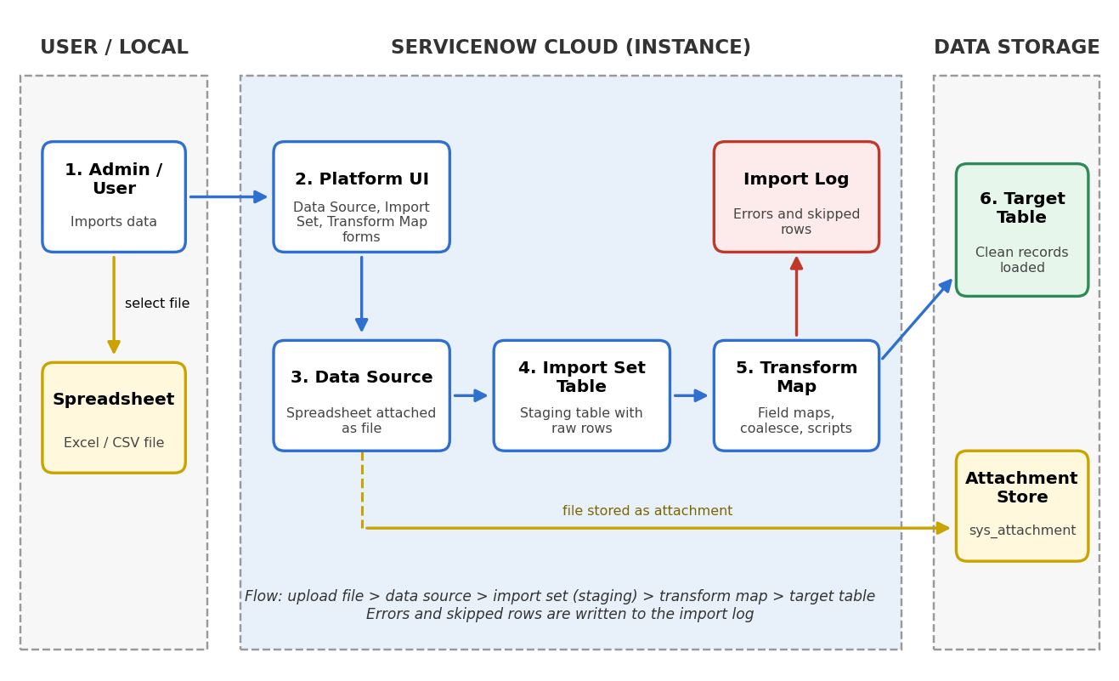 | Guidelines:  - Include all the processes (As an application logic / Technology Block)  - Provide infrastructural demarcation (Local / Cloud)  - Indicate external interfaces (third party API's etc.)  - Indicate Data Storage components / services  - Indicate interface to machine learning models (if applicable)
Table-1 : Components & Technologies:
S.No | Component | Description | Technology
1. | User Interface | ServiceNow platform UI where the admin creates the Data Source, Import Set and Transform Map and starts the import | ServiceNow Next Experience UI (HTML, CSS, JavaScript)
2. | Application Logic-1 | Data Source setup: the spreadsheet (Excel/CSV) file is attached and selected as the source of data | ServiceNow Data Source (File type, Excel/CSV)
3. | Application Logic-2 | Loading the spreadsheet rows into a staging (Import Set) table | ServiceNow Import Set, Import Set Table
4. | Application Logic-3 | Transform map with field maps and Coalesce to move staging data into the target table without duplicates | ServiceNow Transform Map, Field Maps, Coalesce
5. | Database | Target table that stores the final transformed records, plus staging and log tables | ServiceNow relational database (Now Platform tables)
6. | Cloud Database | Database service hosted on the cloud with the ServiceNow instance | ServiceNow Cloud (Now Platform)
7. | File Storage | Storage of the uploaded spreadsheet file used by the data source | ServiceNow Attachments (sys_attachment)
8. | External API-1 | Optional: REST API to push spreadsheet data into an Import Set table from outside | ServiceNow Import Set REST API (optional)
9. | External API-2 | Optional: MID Server for data that is not directly reachable from the cloud instance | ServiceNow MID Server (optional)
10. | Machine Learning Model | Not used in this project | Not applicable
11. | Infrastructure (Server / Cloud) | Application deployment on cloud. Cloud server configuration: ServiceNow developer instance. Local server configuration: not used | ServiceNow Personal Developer Instance (PDI), cloud hosted
Table-2: Application Characteristics:
S.No | Characteristics | Description | Technology
1. | Open-Source Frameworks | Open file formats and open scripting used: spreadsheet files (.xlsx/.csv) and JavaScript in transform scripts | JavaScript, CSV / XLSX formats
2. | Security Implementations | Role-based access (only admin / import_admin roles can import), ACLs on tables, secure HTTPS access to the instance | Roles, ACLs, HTTPS / TLS
3. | Scalable Architecture | Import sets are staged and transformed in batches on a cloud multi-tier platform, so large files can be handled | ServiceNow multi-tier cloud architecture
4. | Availability | Cloud instance hosted with redundant data centers and failover, so import can be run whenever needed | ServiceNow cloud high availability
5. | Performance | Bulk load through staging table, indexed Coalesce field for fast matching, and scheduled or background transform for big files | Import Set batching, indexes, Scheduled Import

